Name: _________________________________________________

Example slides: Body Surface Area
- To be worked through as a whole group

Example 1: Example 2: Example 3:

Example slides: Intensity Signs
- To be worked through as a whole group
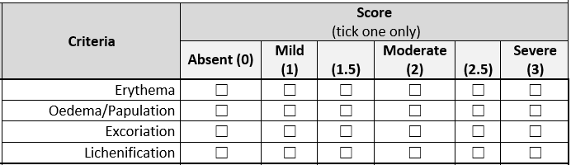
Example 1: Example 2:

Example 3:

Test slides
- To be worked through in pairs initially
- Each person to use a separate scoring sheet (don’t need to agree with each other)
- Mark in next column if correct

Slide 1: Slide 2:

Slide 3: Slide 4:

Slide 5: Slide 6:

Slide 7: Slide 8:

Slide 9: Slide 10:

Slide 11: Slide 12:

Slide 13: Slide 14:

Slide 15: Slide 16:

Slide 17: Slide 18:

Slide 19: Slide 20:

Slide 21:

